The 2017 Pacific Coast Dream Machines Show Returns
Sunday April 30, 2017 to Half Moon Bay Airport
The “Coolest Show on Earth”
By Tony Leopardo © AutoWire.Net

THE COOLEST SHOW ON EARTH ROLLS INTO HALF MOON BAY

Half Moon Bay California's Festival of Magnificent Machines Marks 27th Year

Pacific Coast Dream Machines Show Returns Sunday, April 30, 2017 to Half Moon Bay Airport

World-Class Tricked-Out Cars and Trucks, Fantastic Flying Machines, Custom Motorcycles, Quirky Contraptions, Warbird Flyovers, Dream Machine of the Year Award Headline The Coolest Show on Earth
Freestyle Motocross Stunt Shows, Monster Truck Rides, Unimotorcycle Drag Racing and Spectacular Skydiving Return
Bob Senz’ Big Cacklefest, a Mass Firing-Up of the Engines Debuts!

THE COOLEST SHOW ON EARTH ROLLS INTO HALF MOON BAY
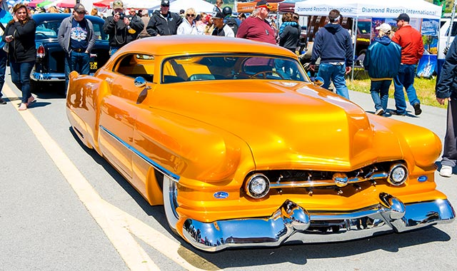
There are car shows, air shows, motorcycle shows, tractor shows, maker fairs, music festivals, food festivals, and living history festivals galore. Mix them all together in one venue on one day and you’ve got Half Moon Bay California’s remarkable, one and only Pacific Coast Dream Machines Show –– marking its 27th year in 2017 with a massive celebration of mechanical ingenuity, power and style.
It's quite simply the “Coolest Show on Earth”. This year’s spectacular 27th annual show will be held on Sunday, April 30, a one-day mega-show, from 10 a.m. to 4 p.m. at Half Moon Bay Airport, located in the picturesque seaside town of Half Moon Bay, CA about 20 miles south of San Francisco.
It's a whimsical, fascinating, amusing, curious and absolutely unique show and tell spectacle featuring 2,000 magnificent driving, flying and working machines from the 20th and 21st centuries. The world's coolest cars of every era and style, model-T fire engines, vintage buses, custom motorcycles, tricked out trucks, sleek streamliners, one-of-a-kind antique engines and tractors and historic military aircraft will be among the mesmerizing displays.

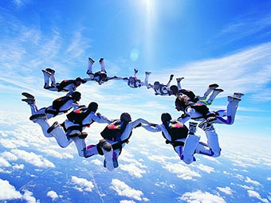

SPECIAL ATTRACTIONS
Among the special attractions this year are the debut of Bob Senz’ Big Cacklefest – a mass synchronized firing-up of the engines of all the magnificent machines on display (10am,12pm, 2pm), spine-tingling vintage warbird flyovers (11am and 1pm), spectacular skydiving performances from the C-47 Skytrain with military style jumps by the experts at Precision Skydiving (11am), electrifying 4-rider freestyle motocross stunt shows (11:30am, 1:30pm, 3:30pm), a special display of legendary builder Jack Costella’s Nebulous Theorem streamliners that have set more than 100 land speed records, side-by-side unimotorcycle drag racing, monster truck rides, helicopter and plane rides, plus refurbished fly-wheel engines from the Early Days Gas Engine & Tractor Association and meticulously restored logging equipment and artifacts from Willits CA-based Roots of Motive Power.

THE WORLD’S COOLEST CARS
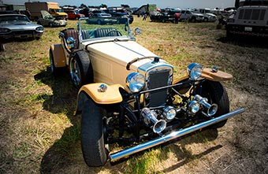
It's one of the west coast's biggest, baddest gatherings of the world's coolest cars. Spectators will get a rare up-close look at antique horseless carriages and Ford Model T's, fanciful touring and luxury cars, powerful sports cars, custom cars and street rods, muscle cars, vintage and modern era high-performance race cars, quirky art and pedal cars, modified street machines with cutting edge styles, exotic high-performance cars, stylish European cars, ultra cool low-riders, sporty compacts, modified imports with flashy graphics, fashionable hip-hop urban show cars, homebuilt kit cars, super-charged turbo cars and trucks, “green” technology/alternative fuel vehicles, streamliners, dragsters, funny cars, gassers, and jet cars.

FANTASTIC FLYING MACHINES
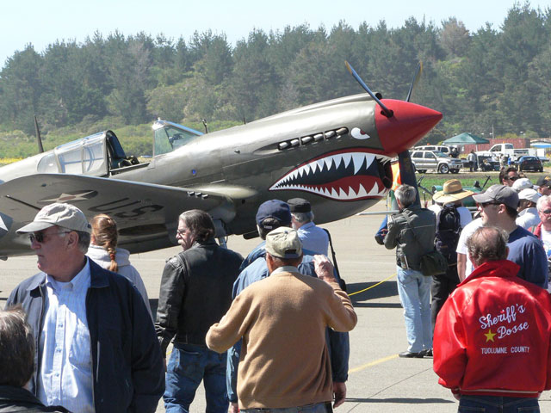
Hundreds of aviation wonders are expected to be on display –– headlined by legendary vintage warbirds like the B-25 Bomber and C-47 Skytrain plus stylish homebuilts, classics from the ‘40s and ‘50s, sport and ultralight aircraft. Inspiring flyovers by some of our nation’s most storied military aircraft promise to be a fan favorite – all flown in memory of the late Eddie Andreini Sr., world-renown aerobatics pilot, founding Dream Machines contributor and pillar in the Half Moon Bay community. Plus there's P-51 “Mustang Madness” –– a spectacular display of America’s premier World War II fighter along with YAK Russian fighters and an impressive array of L-39, T-6 and T-28 military fighters and trainers. Thrilling rides will be offered in helicopters and vintage bi-planes.

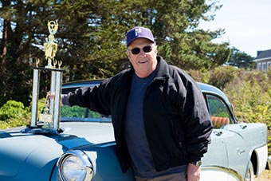

DREAM MACHINE OF THE YEAR AWARD
The "DRIVE Magazine Dream Machine of the Year” returns with editors from Beckett Media’s DRIVE Magazine on hand to select a winner from the thousands of magnificent machines on display. A special trophy will be awarded at a recognition ceremony during the show (3pm at the music stage).

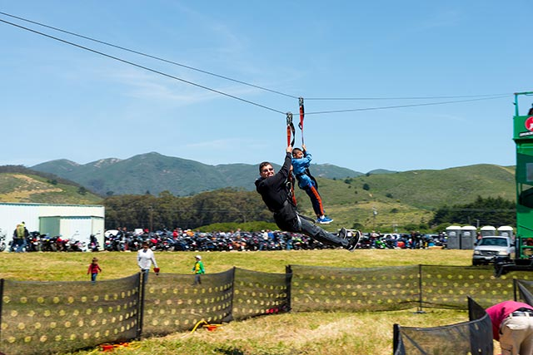

SUPER DUPER KIDZ FUNZONE
The attractions for youngsters are awesome and endless in the Super Duper Kidz Funzone: an ultra-thrilling zip line, Zorbs – the Human Hamster Ball race track, bungee jump, rock climbing wall, wild and wacky waterballerz, and a remote-controlled NASCAR race track.

FABULOUS FOOD AND DELICIOUS DRINK
There will be plenty of delectable food and delicious coastal-infused drink with a custom cocktail and beer just for the show – The Aviator, a refreshing gin cocktail and Bloody Mary’s from Half Moon Bay Distillery and Classic Motorhead Ale from Half Moon Bay Brewing Company plus tasty varietals from Half Moon Bay’s Barterra Winery and craft cocktails from Longboard Margarita Bar.

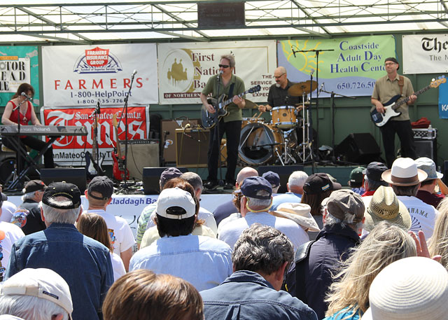

SMASHING ENTERTAINMENT
The sensational all-day music lineup features the fabulous Eagles tribute band The Lyin’ I’s (2pm), Grammy-nominated zydeco and accordion legend Andre Thierry (11:30am), and Wavelength: a Tribute to Van Morrison (10am). Special thanks to music organizer Grant Walters for his longtime support.

SATURDAY HANGAR DINNER
The Half Moon Bay Pilots Association Saturday Hangar Dinner will be held on Saturday, April 29 at the Andreini family hangar at Half Moon Bay Airport. Preview some of the historic aircraft and custom cars that will be displayed at the Dream Machines Show and enjoy a festive barbecue tri-tip dinner party. Tickets are $30 per person, available at the door which open at 5:30 pm. Parking is on the airport field – enter off Capistrano Road.

MOBILE APP + FREE WI-FI
Download the free Dream Machines mobile app developed by Half Moon Bay’s Phondini Partners. This fantastic app is designed to enhance the event experience for users by providing everything from a fact sheet with key details, information on special attractions, a detailed site map keyed to specific attractions, event and entertainment schedule, door-to-door directions, push messaging alerts, social media integration, and visitor information via a full-function version of Phondini's iCoastside app. The app, scheduled to be available in mid April, is available for the Apple and Android markets.
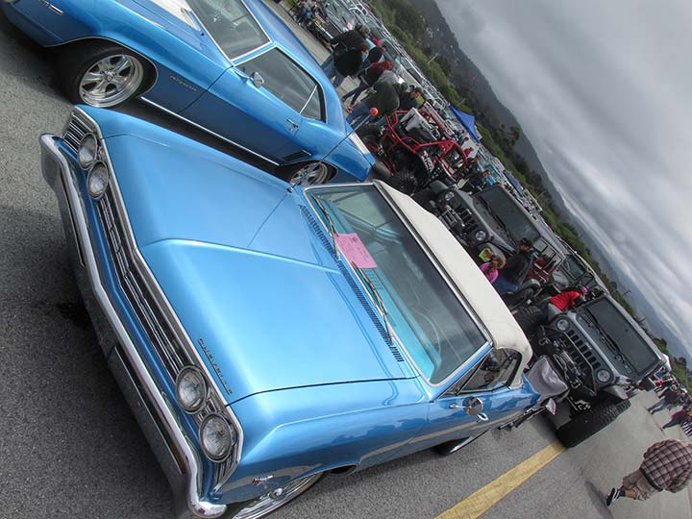

REGISTER YOUR MACHINE
To show a car, the registration fee is $40 ($50 for entries postmarked after April 15) and includes a dash plaque and admission for two people. Register online.

SPECTATOR ADMISSION
Spectator admission is $25 for adults (age 18-69), $15 for ages 11-17 and 70+, Free for kids age 10 and under. Tickets are available at the gate only. There is a separate $10 per vehicle spectator parking fee.

PARKING
There is a separate $10 per vehicle spectator parking fee. There is a designated area for bicycle parking at the south end of the airport/Mezza Luna gate. Click here for the event map.

HANDICAPPED PARKING
There will be specially marked handicapped parking on the airport grounds. Attendants will be on-site to direct you. Click here for the event map.

FIRST AID / LOST & FOUND
First aid and lost and found is located at the Information Booth – please refer to the event site map. Click here for the event map.

SHUTTLE BUS
A special shuttle bus is available to shuttle visitors from the auto display areas at the central/south end of the airport to the aircraft display area at the north end. Click here for the event map.

NO PETS, PLEASE
Please be considerate. For the safety, comfort, and courtesy of your pets and festival-goers, please leave your pets at home. Large crowds and noise make it a very stressful and dangerous environment for pets.

EVENT DATE / HOURS
The show is open to the public on Sunday, April 30 from 10 am to 4 pm. Gates open at 6:30 for those that have registered their machine or plan to register the day of show.

EVENT LOCATION
Half Moon Bay Airport, 9850 N. Cabrillo Highway, Half Moon Bay CA 94019 – located on Highway 1, about 20 miles south of San Francisco and 5 miles north of Highway 92. Get directions.

EVENT BENEFICIARY
The show benefits the Coastside Adult Day Health Center. Thanks in part to fund-raising support from Dream Machines, the sparkling new Coastside Adult Community Center opened in 2014. Drop by the fabulous new facility shared with Senior Coastsiders at 925 Main Street in Half Moon Bay.

INFO-LINE / WEB/SOCIAL MEDIA
For event information and registration forms, call the info-line at 650-726-2328 or visit the website. “Like” our Facebook page or follow us on Twitter and Instagram.

Event Details
- A Warm Welcome & Thanks
- About the Event
- Quick Facts
- Schedule of Events
- Date & Time
- Directions & Map
- Ticket Prices
- Event Map (PDF)
- Pilot Fly-In Information
- Lodging Information
- Enter Your Dream Machine

Registration
Enter Your Dream Machine

Event Beneficiary
PCDM is the largest fundraiser of the year for the Coastside Adult Day Health Center.

LOCATION & DATES
Half Moon Bay Airport
Half Moon Bay, California
April 30, 2017
10am – 4pm
The 27th Annual Pacific Coast Dream Machines Show Review: provided by:
Tony Leopardo © AutoWire.Net “Tony the Car Guy” is an automotive writer, editor and publisher in the San Francisco Bay Area. If you have a question or comment for Tony send it to TonyLeo@pacbell.net or visit AutoWire.Net at www.autowire.net - And remember: “ You Are What You Drive © ”

Column Name: The “Coolest Show on Earth”
Topic: The 27th Annual Pacific Coast Dream Machines Show
Word Count: 1,611
Photo Caption: The 2017 Pacific Coast Dream Machines Show
Photo Credits: Miramar Events Internet Media
Series #: 2017- 10

